ZOMBIES VS PLANTS

Emmanuella Boamah
Computer Science Coursework

Candidate Number:
Center Number: 33435

Analysis:
Design:
Implementation:
Testing:
Evaluation:

Analysis

Background
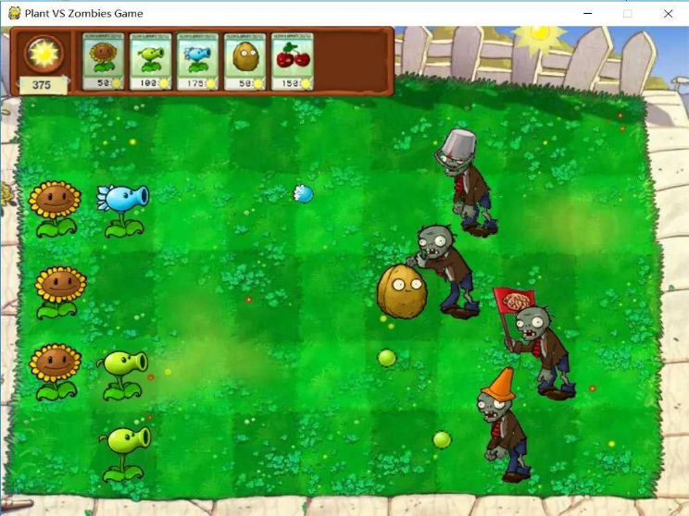
Plants vs. Zombies was designed by George Fan. Imagining a more defence-oriented version of one of his previous titles, Insaniquarium (2001, a strategy game that involves growing an aquarium's population while simultaneously protecting the fishes from an alien invasion.), and having played some Warcraft III tower defence mods, he was inspired to make a tower defence game.
Plants vs. Zombies is a tower defence video game in which the player defends a house from zombies. The lawn is divided into a grid, with the player's house to the left. The player places different types of plant on individual squares of the grid. Each plant has a different style of defence, such as shooting, exploding, and blocking.

Plants vs. Zombies took three and a half years to make Much of the first year of development focused on Adventure mode. Semple began working on ideas later used for Mini-Games mode.

Finally on April 22, 2009, PopCap released an official game trailer of Plants vs. Zombies on YouTube, the game was officially released on May 5, 2009, for PC and Mac.
In May 2013, PopCap Games released a trailer revealing a sequel to the first game, titled “Plant vs. Zombies 2: It's About Time”, the game featured new locations and plants along with the addition of plant food, a power-up that can be used to enhance a plant for a short period and can either be bought using in-game currency or acquired by defeating zombies that are glowing green.

Plants vs. Zombies (abbreviated as PvZ) is a tower defence video game developed and originally published by PopCap Games and it is the first instalment in the Plants vs. Zombies series. The game involves homeowners who use a variety of different plants to prevent waves of zombies from entering their houses and "eating their brains". It was first released on May 5, 2009, and it originally (and initially) was made available on Steam for Microsoft Windows and macOS. An iPhone version for iOS was released on February 15, 2010, and an HD version for the iPad was released on March 31, 2010.

REFERENCES
https://en.wikipedia.org/wiki/Plants_vs._Zombies_(video_game)
https://dl.acm.org/doi/pdf/10.5555/2812774.2812779
https://www.programmersought.com/images/452/9c4fbf08a7f4dc0b92b26b8161ec2aec.JPEG
https://plantsvszombies.fandom.com/wiki/Plants_vs._Zombies

Interview with User

Me: Hi Gianna, do you want to be my end user for my computer science project
Gianna: Yes
Me: Great! I'm planning to make a game. What kind of game would you like?
Gianna: I’m thinking you could make a game like plants vs zombies .
Me: yes, that seems like a good idea, do you want it exactly like the original version or do you want to create your own version of the game.
Gianna: I would like to be creative and create a different version of the game but with plants still being the hero and zombies trying to attack.
I would like to be able to move the plant and shoot the zombies as they are coming towards me.
After I kill a total of 10 zombies I win, and if a zombie eats me then I am dead, so I lose.
Me: okay, that seems like a good idea.

Later
Me: Hello Gianna, I’m currently making the plants and zombies and I wanted to ask you some questions about the way you want the gam to function
Gianna: Hello, sure that’s fine.
Me: which keys would you like the plant to use to move it around?
Gianna: I would like to use the WASD and the SPACE button to shoot
Me: okay, and as I’m going on with this project, I realised I need more requirements to make the game a bit better, so I wanted to know if there was anything that you wanted to add
Gianna: I think it would be good if we added a multiplayer version where there are 2 plants playing together against the zombies
Me: Sure, and how would you want that work
Gianna: I was thinking we make the 2 players kill as many zombies as possible until they have scored 15 points to win but if one of the plants gets eaten by the zombies then they lose.
Me: Okay that’s seems like a good idea to me, now I’m currently making the games state which is where the single player will play and I wanted to ask what you would like to appear on the screen while the game is playing, for example for the score to be shown or something else
Gianna: Okay yes, I think I want the number of players to be shown so either 1 or 2 for single player or multiplayer and the scores of the plants to be shown.
Me: That’s perfect, now since we have 2 players will need other keys to be used to move the plants and shoot
Gianna: yes, for the second plant we can use the IJKL keys to move the plants around and the ENTER button to shoot
Me: okay! Since you told me that you want a multiplayer game and a single player game then in the main menu as soon as the game starts there will be a play option and a multiplayer option, is that okay?
Gianna: Yes, that okay, but I think you should also add a exit button so it’s easy for the user to exit the game.
Me: okay thank you

Later
Me: I’ve now finished doing the game state where the main game happens, and I want to ask you how would you like to let the player know when they have won or lost?
Gianna: Maybe we can make it that right after a player loses or wins and a screen saying you have lost or won will appear on the screen and it should give the option to go back to main menu if it wants to replay or to exit the game.
Me: Yes, we could do this by creating another class, thank you for your time.

USER REQUIREMENTS
1~ Main menu to be displayed as soon as the game starts, giving the user options to choose between playing on their own, multiplayer or exiting the game
2~ Hoover available when going on buttons
3~ Only one type of plant available for the user to use, unlike the original plants vs zombies where you get multiple options, and user must be able to move plants
4~ If multiplayer then there will be 2 plants on the screen, each with different keys to move and shoot
5~ Plants and zombies to be animated
6~ Zombies to appear and automatically walk towards the other part of the screen where the plants are located
7~ Plant to be able to shoot the zombies to kill them and increase score
8~ If plant has killed more 10 zombies, then it has won, but if a zombie eats the plant then it has lost
9~ If multiplying then the 2 users are playing together against the zombies, and they win when they have killed 15 zombies and lose when one of them is eaten by a zombie
10~ When the plant loses or wins the user will be automatically sent to a high score state that tells the user they have lost or won and it gives them the option to go back to main menu or exit the game
11~ Score and number of players to be shown on screen
12~ Zombies to be faster in multiplayer

PROPOSED USER STRATEGY
The purpose of the game is for the plants to kill a certain amount of zombies without being eaten

The purpose of the zombies is to automatically walk towards the other pat of the screen trying to eat a plant

I will be creating different game states for the multiplayer version and the normal version in the main menu

I will use the wasd keys to move a plant and the ijkl keys to move another

Design
These are the sprite sheets that I will be using in my game, to make the sprites animated.
This is the Zombie sprite sheet that I will.

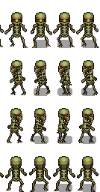
This is the plant sprite sheet that I will use.
Add menu section
This is the background image i'm planning to use for the main menu


And this is how my main menu will look like

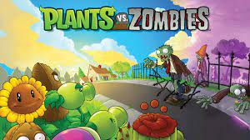

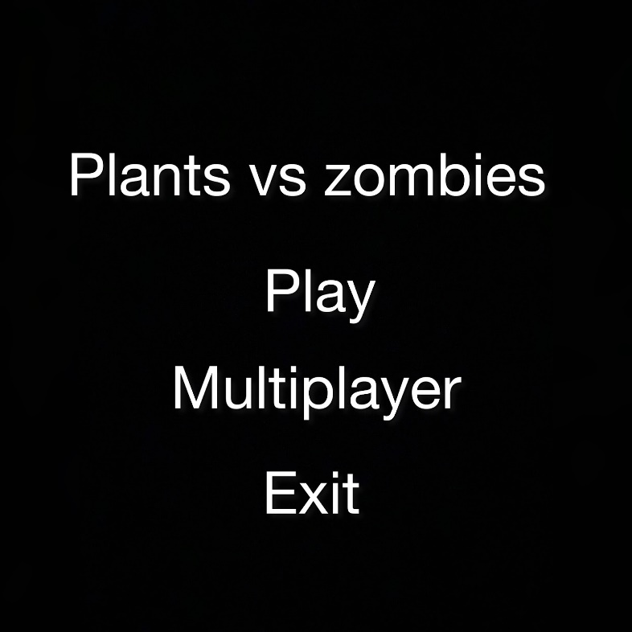
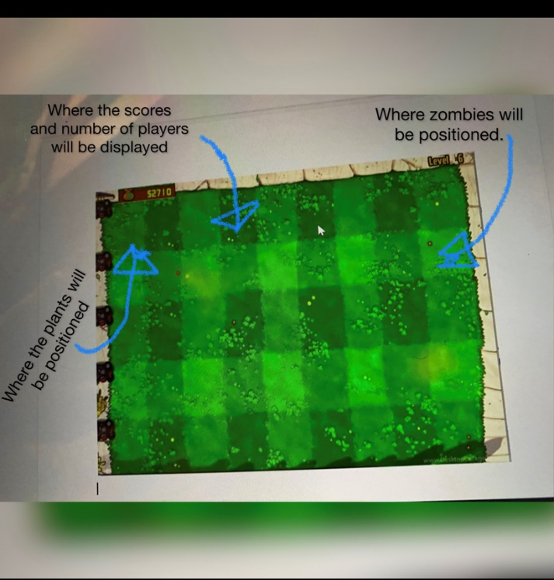
This is also the background i will be using for when the game starts and i have annotated it with where i will be positioning the sprites and where the scores and player number will be displayed.

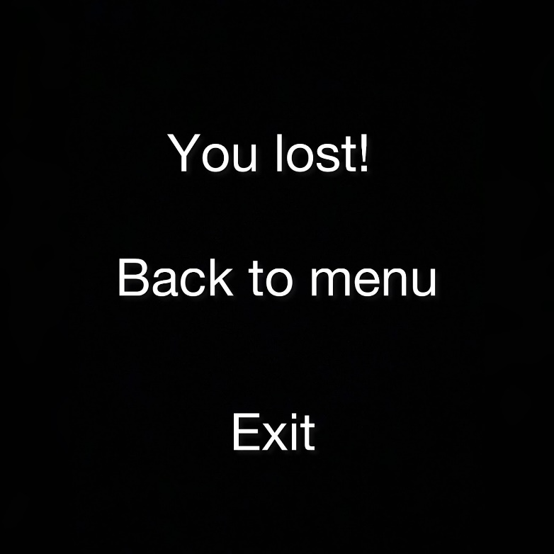
When the player loses this is the screen that will automatically come on, it will tell them that they have lost and it will give them the option to go back to the main menu or exit the game
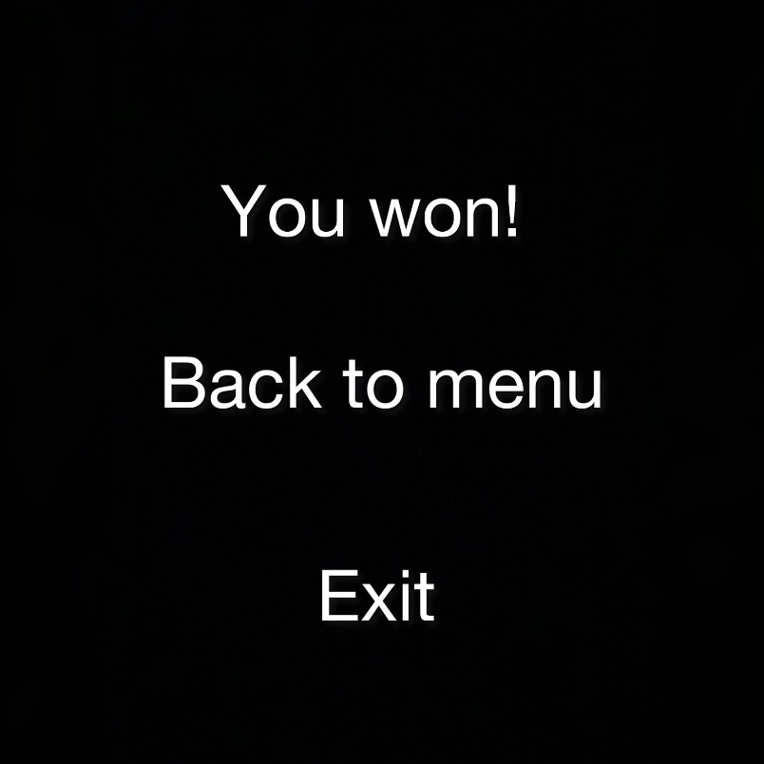
When the player loses this is the screen that will automatically come on, it will tell them that they have lost and it will give them the option to go back to the main menu or exit the game

DESIGN

INTRODUCTION

I will be coding my game with C# because it can be used to create almost anything but is particularly strong at building Windows desktop applications and games. I'll code using OOP as it allows me to break the program into bit-sized problems that can be solved easily (one object at a time) and By using inheritance, we can eliminate redundant code and extend the use of existing classes.

I will be using an external library called MonoGame because it is great for 2D development, as it was initially built for 2D projects and has great customization tools specifically for 2D development,as well as that it will allow me to manage the graphics of my project, the game will run at 60 Frames Per Second and each object will be re-drawn onto the screen every time the frame is updated. These draw, update and graphics retrieval methods can all be methods inside each individual object class, all the necessary graphics for each object will be retrieved using MonoGame's SpriteBatch.

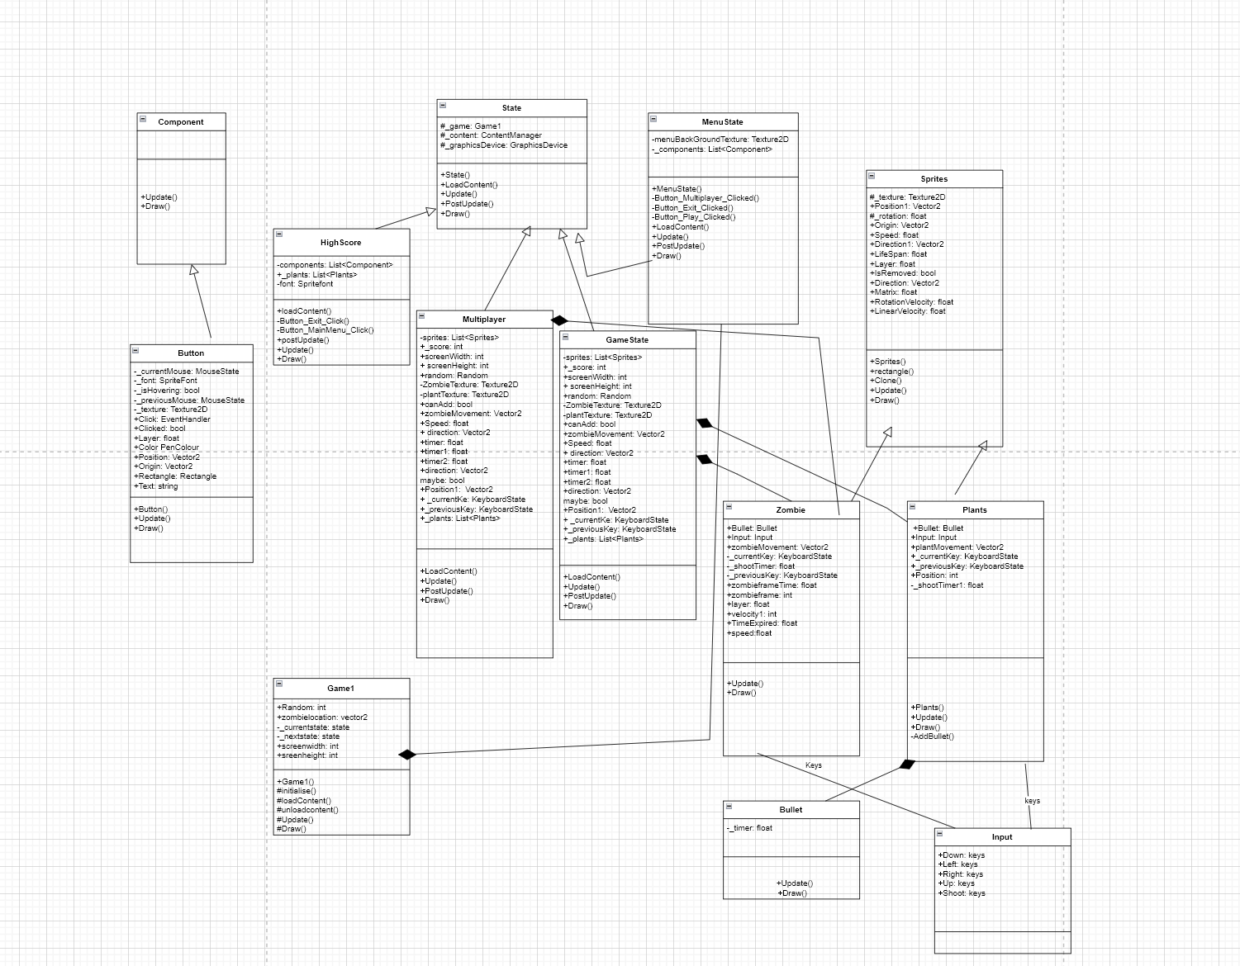
UML DIAGRAM

The UML Diagram above illustrates the relationships between all the objects in my project.
plan to use separate class files for all of these objects, and they will interact with each-other
in a standard Object-Oriented manner.
Design and Diagrams

When the game first starts the main menu will be displayed, giving the user the option to play on their own multiplay or see the highscore. This is the screen that will appear
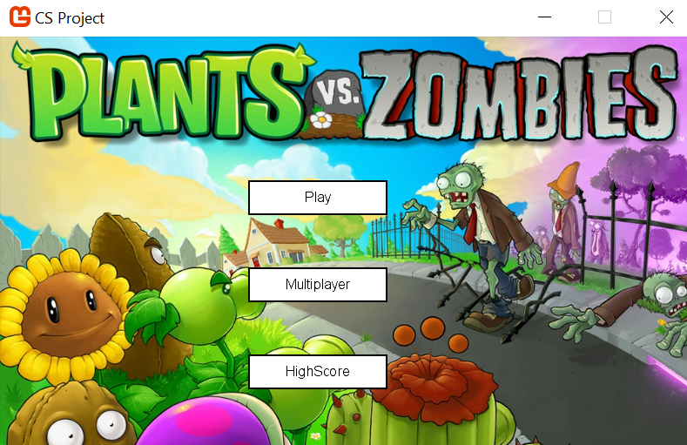

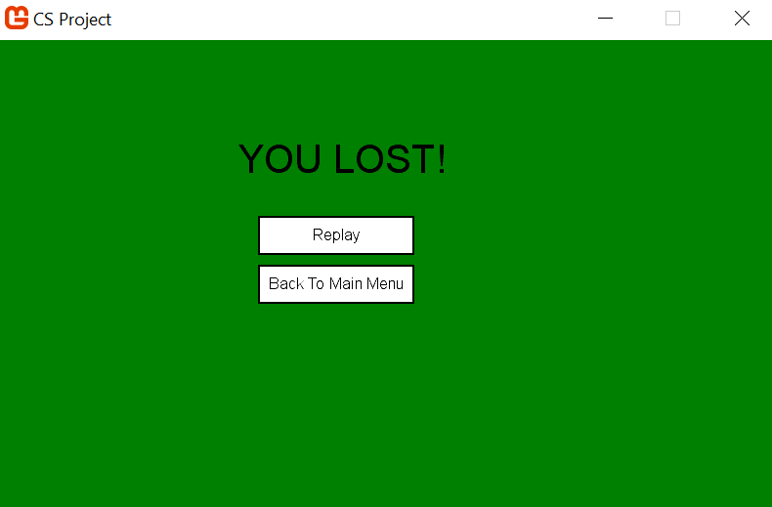
When the zombie eats the plant before the plants kills 10 zombies then the game will change its state to the highscore state where a screen saying “you have lost” with 2 buttons with options given to either replay the game will reset everything to the beginning. The other option will be to go back to the main menu where they will be given the option to play on their own or multiplay
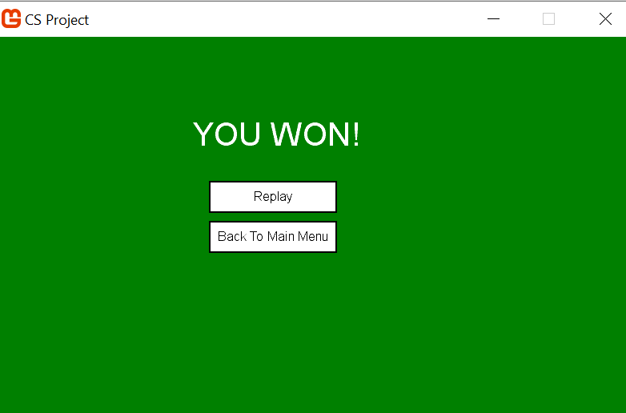
Explain this picture
As soon as the player starts the game there will be a plant in the top corner of the screen and the user will be able to move it around using the WASD keys and shooting the zombies with the space keys
The zombies will start appearing from the right side of the screen and start walking forward towards the other side of the screen

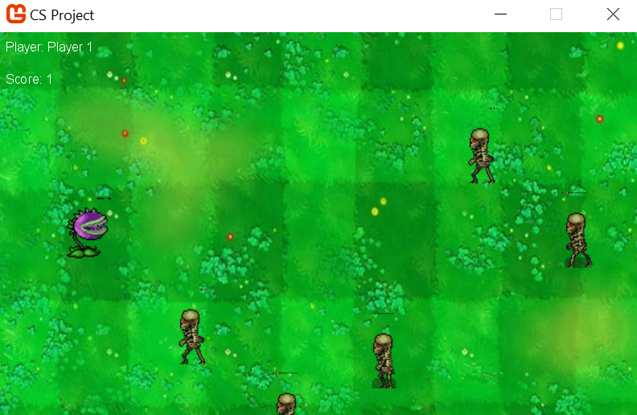
PSEUDO CODE
Collision between bullets and zombies
For each sprite from sprites do
if(sprite is bullet) then
Continue
if (sprite.Rectangle.Intersects(this.Rectangle)) then
sprite.IsRemoved 🡨 true
_score 🡨_score + 1
End if
End if

To remove zombie if it intersects with the bullet
FOR i 🡨0 TO sprites.Count DO
Sprite 🡨 sprites[i];
if (sprite is Zombie)
if (sprite.IsRemoved)
sprites.RemoveAt(i);
i🡨 i-1
_score🡨_score + 1
End if
End if
End for

IMPLEMENTION

Butoon
using Microsoft.Xna.Framework;
using Microsoft.Xna.Framework.Graphics;
using Microsoft.Xna.Framework.Input;
using System;
using System.Collections.Generic;
using System.Linq;
using System.Text;
using System.Threading.Tasks;

namespace CS_Project
{
public class Button : Component
{
#region Fields

private MouseState _currentMouse;

private SpriteFont _font;

private bool _isHovering;

private MouseState _previousMouse;

private Texture2D _texture;

#endregion

#region Properties

public event EventHandler Click;

public bool Clicked { get; private set; }
public float Layer { get; set;
}

public Color PenColour { get; set; }

public Vector2 Position { get; set; }

public Vector2 Origin
{
get
{
return new Vector2(_texture.Width / 2, _texture.Height / 2);
}
}
//for button
public Rectangle Rectangle
{
get
{
return new Rectangle((int)Position.X - ((int)Origin.X), (int)Position.Y - (int)Origin.Y, _texture.Width, _texture.Height);

}
}
public string Text { get; set; }

#endregion

#region Methods

public Button(Texture2D texture, SpriteFont font)
{
_texture = texture;

_font = font;
PenColour = Color.Black;

}

public override void Draw(GameTime gameTime, SpriteBatch spriteBatch)
{
var colour = Color.White;

if (_isHovering)
colour = Color.Gray;
//draw button
spriteBatch.Draw(_texture, Position,null, colour,0f,Origin,1f,SpriteEffects.None,Layer);
//draw text in button
if (!string.IsNullOrEmpty(Text))
{
var x = (Rectangle.X + (Rectangle.Width / 2)) - (_font.MeasureString(Text).X / 2);
var y = (Rectangle.Y + (Rectangle.Height / 2)) - (_font.MeasureString(Text).Y / 2);

spriteBatch.DrawString(_font, Text, new Vector2(x,y), PenColour,0f,new Vector2(0,0),1f,SpriteEffects.None,Layer+0.01f);
}
}

public override void Update(GameTime gameTime)
{
_previousMouse = _currentMouse;
_currentMouse = Mouse.GetState();

var mouseRectangle = new Rectangle(_currentMouse.X, _currentMouse.Y, 1, 1);

_isHovering = false;

if (mouseRectangle.Intersects(Rectangle))
{
//if mouse is in the buttons rectangle then show hoover
_isHovering = true;

if (_currentMouse.LeftButton == ButtonState.Released && _previousMouse.LeftButton == ButtonState.Pressed)
{
Click?.Invoke(this, new EventArgs());
}
}
}

#endregion
}
}

MENUSTATE
using System;
//using CS_Project.Control
using Microsoft.Xna.Framework.Input;
using System.Collections.Generic;
using System.Linq;
using System.Text;
using System.Threading.Tasks;
using Microsoft.Xna.Framework;
using Microsoft.Xna.Framework.Content;
using Microsoft.Xna.Framework.Graphics;

using CS_Project;

namespace CS_Project
{
public class MenuState : State
{
private Texture2D menuBackGroundTexture;

private List<Component> _components;

public MenuState(Game1 game, GraphicsDevice graphicsDevice, ContentManager content)
: base(game,graphicsDevice,content)
{

var buttonTexture = _content.Load<Texture2D>("Button3");//do i have to add var to uml digram
var buttonFont = _content.Load<SpriteFont>("Font" );
menuBackGroundTexture = _content.Load<Texture2D>("backg1");

//creatig the buttons
var newGameButton = new Button(buttonTexture, buttonFont)
{
Position = new Vector2(365, 185),
Text = "Play",

};
newGameButton.Click += Button_Play_Clicked;
var MultiplayerGameButton = new Button(buttonTexture, buttonFont)
{

Position = new Vector2(365, 285),
Text = "Multiplayer",

};
MultiplayerGameButton.Click += Button_Multiplayer_Clicked;

var ExitButton = new Button(buttonTexture, buttonFont)
{
Position = new Vector2(365, 385),
Text = "Exit",

};

ExitButton.Click += Button_Exit_Clicked;

_components = new List<Component>()
{
newGameButton,
ExitButton,
MultiplayerGameButton,
};

}
//changing gamestate based on the button pressed
private void Button_Multiplayer_Clicked(object sender, EventArgs args)
{
_game.ChangeState(new Multiplayer(_game, _graphicsDevice, _content));
{

}
}

private void Button_Exit_Clicked(object sender, EventArgs e)
{

_game.Exit();
}

private void Button_Play_Clicked(object sender, EventArgs e)
{

_game.ChangeState(new GameState(_game, _graphicsDevice, _content));
{

}
}

public override void Draw(GameTime gameTime, SpriteBatch spriteBatch)
{
spriteBatch.Begin();

spriteBatch.Draw(menuBackGroundTexture, new Vector2(0, 0), null, Color.White, 0f,
Vector2.Zero, 0.78f, SpriteEffects.None, 0f);
foreach (var component in _components)
component.Draw(gameTime,spriteBatch);
spriteBatch.End();

}

public override void PostUpdate(GameTime gameTime)
{

}

public override void Update(GameTime gameTime)
{
foreach (var component in _components)
component.Update(gameTime);
}

public override void LoadContent()
{

}
}
}

COMPONENT

using Microsoft.Xna.Framework;
using Microsoft.Xna.Framework.Graphics;
using System;
using System.Collections.Generic;
using System.Linq;
using System.Text;
using System.Threading.Tasks;

namespace CS_Project
{
public abstract class Component
{
public abstract void Draw(GameTime gameTime, SpriteBatch spriteBatch);

public abstract void Update(GameTime gameTime);

}
}

STATE
using Microsoft.Xna.Framework;
using Microsoft.Xna.Framework.Content;
using Microsoft.Xna.Framework.Graphics;
using System;
using System.Collections.Generic;
using System.Linq;
using System.Text;
using System.Threading.Tasks;

namespace CS_Project {
public abstract class State
{
protected Game1 _game;

protected ContentManager _content;

protected GraphicsDevice _graphicsDevice;

public State(Game1 game, GraphicsDevice graphicsDevice, ContentManager content)
{
_game = game;
_graphicsDevice = graphicsDevice;
_content = content;

}

public abstract void LoadContent();
public abstract void Update(GameTime gameTime);

public abstract void PostUpdate(GameTime gameTime);

public abstract void Draw(GameTime gameTime, SpriteBatch spriteBatch);
}
}

Gamestate
using System;
using System.Collections.Generic;
using System.Linq;
using System.Text;
using System.Threading.Tasks;
using Microsoft.Xna.Framework;
using Microsoft.Xna.Framework.Content;
using Microsoft.Xna.Framework.Graphics;

using Microsoft.Xna.Framework.Input;

namespace CS_Project

{
public class GameState : State
{

public static List<Sprites> sprites;

public static int _score;

public static int screenWidth = 1920;
public static int screenHeight = 1080;
public static Random random;
private SpriteFont _font;
private Texture2D ZombieTexture;
private Texture2D plantTexture;
public bool CanAdd { get; set; }

Vector2 zombieMovement = new Vector2(0, 0);
public float Speed = 2f;
// public bool see;
public Vector2 direction;
// public Vector2 Position;
public float timer;
public float time2 { get; set; }
public float time1;
public Vector2 Position1;

public KeyboardState _currentKey;
public KeyboardState _previousKey;
public static List<Plants> _plants;

public GameState(Game1 game, GraphicsDevice graphicsDevice, ContentManager content)
: base(game, graphicsDevice, content)
{

content.RootDirectory = "Content";
_font = _content.Load<SpriteFont>("Font");
ZombieTexture = _content.Load<Texture2D>(@"zombie_n_skeleton2");

plantTexture = _content.Load<Texture2D>(@"1Plantstry3-removebg-preview");
//background image
sprites = new List<Sprites>()
{
new Sprites(_content.Load<Texture2D>("Background"))
{
Position1=new Vector2(-50,-100)

}
};

//to make plants appear on screenwithout creating new plants

Random rand = new Random();
sprites.Add(new Plants(plantTexture)//adding plants
{
Bullet = new Bullet(_content.Load<Texture2D>("laserBullet")),
Input = new Input()
{
Up = Keys.W,
Down = Keys.S,
Left = Keys.D,
Right = Keys.A,
Shoot = Keys.Space,
},

});

_score = 0; //starts the score from 0
_plants = sprites.Where(c => c is Plants).Select(c => (Plants)c).ToList();

}

public override void LoadContent()
{

}
public override void Update(GameTime gameTime)
{

timer += (float)gameTime.ElapsedGameTime.TotalSeconds;

time2 = 3f;
//add random zombies graduallly and move them towards thde opposite side of the screen
CanAdd = false;
if (timer > time2)
{
timer = 0;
CanAdd = true;
time1 = time2 - 0.1f;
}
Random rand = new Random();
if (CanAdd == true)
{
sprites.Add(new Zombie(ZombieTexture)
{

Position1 = new Vector2(700, rand.Next(0, 500)),
});

}

foreach (var sprite in sprites.ToArray())
sprite.Update(gameTime, sprites);
//if you pressthe escape button it will go back to main menu
if (Keyboard.GetState().IsKeyDown(Keys.Escape))
{
_game.ChangeState(new MenuState(_game, _graphicsDevice, _content));
{

}
}

}

public override void PostUpdate(GameTime gameTime)
{

int count = sprites.Count;
for (int i = 0; i < count; i++)
{
foreach (var child in sprites[i].Children)
sprites.Add(child);

sprites[i].Children.Clear();
}
//if zombie is the sprite that intersepted with the bullet rectabgle
//then the zombie will dissapear and the players score will increase by 1
for (int i = 0; i < sprites.Count; i++)
{
var sprite = sprites[i];
if (sprite is Zombie)
{
if (sprite.IsRemoved)
{
sprites.RemoveAt(i);
i--;
_score++;

}
}
}

for (int i = 0; i < _plants.Count; i++)
{//if plants is the sprite that intersepted with the zobies rectabgle
//then the plant will dissapear and go to the highscorestate (this means the player has lost

var plants1 = _plants[i];
if (plants1 is Plants)
{
if (plants1.IsRemoved)
{
_plants.RemoveAt(i);

_game.ChangeState(new Highscore(_game, _graphicsDevice, _content));
{

}

}
}

}// if the plants kills more 10 zombies then it haswon and it will directed to the highscorestate
if (_score > 9)
{
_game.ChangeState(new Highscore(_game, _graphicsDevice, _content));
{

}
}
}

public override void Draw(GameTime gameTime, SpriteBatch spriteBatch)
{
spriteBatch.Begin();

foreach (var sprite in sprites)
sprite.Draw(spriteBatch);

spriteBatch.End();
spriteBatch.Begin();

float x = 10f;
//scores and number of players to be shown on the top left of the screen
spriteBatch.DrawString(_font, "Players: 1", new Vector2(x, 10f), Color.White);
spriteBatch.DrawString(_font, "Score: " + _score, new Vector2(x, 50f), Color.White);

x += 150;

spriteBatch.End();
}

}

}

Multiplayer
using System;
using System.Collections.Generic;
using System.Linq;
using System.Text;
using System.Threading.Tasks;
using Microsoft.Xna.Framework;
using Microsoft.Xna.Framework.Content;
using Microsoft.Xna.Framework.Graphics;
using System.Runtime.InteropServices;
using Microsoft.Xna.Framework.Input;

namespace CS_Project

{
public class Multiplayer : State
{

public static List<Sprites> sprites;

public static int _score;

public static int screenWidth = 1920;
public static int screenHeight = 1080;
public static Random random;
private SpriteFont _font;
private Texture2D ZombieTexture;
private Texture2D plantTexture;
public bool CanAdd { get; set; }

Vector2 zombieMovement = new Vector2(0, 0);
public float Speed = 2f;
// public bool see;
public Vector2 direction;
// public Vector2 Position;
public float timer;
public float time2 { get; set; }
public float time1;
public Vector2 Position1;

public KeyboardState _currentKey;
public KeyboardState _previousKey;
public static List<Plants> _plants;

enum Direction
{
down,
left,
right,
up,
}

Direction zombiedirection = Direction.down;
public Multiplayer(Game1 game, GraphicsDevice graphicsDevice, ContentManager content)
: base(game, graphicsDevice, content)
{
ZombieTexture = _content.Load<Texture2D>(@"zombie_n_skeleton2");
var bulletTexture = _content.Load<Texture2D>("laserBullet");
plantTexture = _content.Load<Texture2D>(@"1Plantstry3-removebg-preview");
_font = _content.Load<SpriteFont>("Font");
//background image
sprites = new List<Sprites>()
{
new Sprites(_content.Load<Texture2D>("Background"))
{
Position1=new Vector2(-50,-100)
}
};
//to make plants appear on screenwithout creating new plants

sprites.Add(new Plants(plantTexture)
{
Bullet = new Bullet(_content.Load<Texture2D>("laserBullet")),

Input = new Input()
{
Up = Keys.W,
Down = Keys.S,
Left = Keys.D,
Right = Keys.A,
Shoot = Keys.Space,
},

});

sprites.Add(new Plants(plantTexture)
{
Bullet = new Bullet(_content.Load<Texture2D>("laserBullet")),
Input = new Input()
{
Up = Keys.I,
Down = Keys.K,
Left = Keys.L,
Right = Keys.J,
Shoot = Keys.Enter,
},

});

_score = 0;//starts the score from 0
_plants = sprites.Where(c => c is Plants).Select(c => (Plants)c).ToList();

}

public override void LoadContent()
{

}

public override void Update(GameTime gameTime)
{

//add random zombies graduallly and move them towards thde opposite side of the screen
timer += (float)gameTime.ElapsedGameTime.TotalSeconds;

time2 = 2f;
CanAdd = false;
if (timer > time2)
{
timer = 0;
CanAdd = true;
time1 = time2 - 0.1f;
}
Random rand = new Random();
if (CanAdd == true)
{
sprites.Add(new Zombie(ZombieTexture)
{

Position1 = new Vector2(700, rand.Next(0, 500)),

});

}

foreach (var sprite in sprites.ToArray())
sprite.Update(gameTime, sprites);

//if you pressthe escape button it will go back to main menu
if (Keyboard.GetState().IsKeyDown(Keys.Escape))
{
_game.ChangeState(new MenuState(_game, _graphicsDevice, _content));
{

}
}

}

public override void PostUpdate(GameTime gameTime)
{

//if zombie is the sprite that intersepted with the bullet rectabgle
//then the zombie will dissapear and the players score will increase by 1

int count = sprites.Count;
for (int i = 0; i < count; i++)
{
foreach (var child in sprites[i].Children)
sprites.Add(child);

sprites[i].Children.Clear();
}

for (int i = 0; i < sprites.Count; i++)
{
var sprite = sprites[i];
if (sprite is Zombie)
{
if (sprite.IsRemoved)
{
sprites.RemoveAt(i);
i--;
_score++;

}
}
}
//if plants is the sprite that intersepted with the zobies rectabgle
//then the plant will dissapear and go to the highscorestate (this means the player has lost
for (int i = 0; i < _plants.Count; i++)
{
var plants1 = _plants[i];
if (plants1 is Plants)
{
if (plants1.IsRemoved)
{
_plants.RemoveAt(i);

_game.ChangeState(new Highscore(_game, _graphicsDevice, _content));
{

}
}

}

}// if the plants kills more 14 zombies(total score is 15) then it has
//won and it will directed to the highscorestate
if (_score > 14)
{
_game.ChangeState(new Highscore(_game, _graphicsDevice, _content));
{

}
}

}

public override void Draw(GameTime gameTime, SpriteBatch spriteBatch)
{

spriteBatch.Begin(SpriteSortMode.FrontToBack);

foreach (var sprite in sprites)
sprite.Draw(spriteBatch);

spriteBatch.End();
float x = 10f;
spriteBatch.Begin();
//scores and number of players to be shown on the top left of the screen
spriteBatch.DrawString(_font, "Players: 2 ", new Vector2(x, 10f), Color.White);

spriteBatch.DrawString(_font, "Total Score: " + _score, new Vector2(x, 50f), Color.White);

x += 150;

spriteBatch.End();
}

}
}

Zombies
using System;
using System.Collections.Generic;
using System.Linq;
using System.Text;
using System.Threading.Tasks;
using Microsoft.Xna.Framework;
using Microsoft.Xna.Framework.Content;
using Microsoft.Xna.Framework.Graphics;
using Microsoft.Xna.Framework.Input;
namespace CS_Project
{
class Zombie : Sprites
{

public Bullet Bullet { get; set; }
public Input Input { get; set; }

Vector2 zombieMovement = new Vector2(0, 0);
private KeyboardState _currentKey;
private float _shootTimer = 0;

private KeyboardState _previousKey;
//internal bool maybe;
public float zombieframeTime = 100;
public int zombieframe = 0;
public float layer;
public int velocity1 = 1;
public float TimeExpired;
public float speed;

enum Direction
{
down,
left,
right,
up,
}

Direction zombiedirection = Direction.left;

public Zombie(Texture2D texture)
: base(texture)
{
speed = 0.5f;
Position1 = new Vector2(550, 10);
layer = 0.2f;

}
public override void Update(GameTime gameTime, List<Sprites> sprites)
{
//to make zombie animation and movement
_previousKey = _currentKey;
_currentKey = Keyboard.GetState();

var velocity = Vector2.Zero;
//zombie walking animation
TimeExpired += gameTime.ElapsedGameTime.Milliseconds;
if (TimeExpired > zombieframeTime)
{
zombieframe = (zombieframe + 1) % 3;
TimeExpired = 0;
}

speed = 1 + (float)Game1.Random.NextDouble();
Direction1 = new Vector2((float)Math.Cos(velocity.Y), (float)Math.Sin(velocity.X));
_shootTimer += (float)gameTime.ElapsedGameTime.TotalSeconds;
Position1.X = Position1.X - velocity1;
if (zombiedirection == Direction.left)
{

foreach (var sprite in sprites)
{
if (sprite == this)
continue;
//if rectangle of a sprite intersects with the zombie rectangle then is removed is true
if (sprite.Rectangle.Intersects(this.Rectangle))
{
sprite.IsRemoved = true;

}

}
}
}

public override void Draw(SpriteBatch spriteBatch)
{//draw zombie animation

int X = zombieframe * 32;
int Y = ((int)zombiedirection * 63);

spriteBatch.Draw(_texture, Position1, new Rectangle(X, Y, 33, 63), Color.White, 0f,
Vector2.Zero, 1.5f, SpriteEffects.None, 0f);

}

}
}

Sprites
using Microsoft.Xna.Framework.Input;
using Microsoft.Xna.Framework;
using Microsoft.Xna.Framework.Graphics;
using Microsoft.Xna.Framework.Input;
using System;
using System.Collections.Generic;
using System.Linq;
using System.Text;
using System.Threading.Tasks;

namespace CS_Project
{
public class Sprites : Component, ICloneable
{ //Sprite
protected Texture2D _texture;
public Vector2 Position1;

// public List<Vector2> enemyPosition = new List<Vector2>();
protected float _rotation;
public Vector2 Origin;
public float Speed = 2f;
public Vector2 Direction1;
public float LifeSpan = 0f;
public float Layer;
public bool IsRemoved;

public Vector2 Direction;
public float Matrix;
public float RotationVelocity = 3f;

public float LinearVelocity = 40f;

public Sprites(Texture2D texture)
{

// Origin = new Vector2(_texture.Width / 2, _texture.Height / 2);
_texture = texture;
Children = new List<Sprites>();

}
//rectangle used for collision detection
public Rectangle Rectangle
{
get
{
return new Rectangle((int)Position1.X, (int)Position1.Y, _texture.Width/5, _texture.Height/5);
}
}

public List<Sprites> Children { get; set; }

public virtual void LoadContent()
{

}

public virtual void Update(GameTime gameTime, List<Sprites> sprites)
{

}

public Sprites Parent;
public virtual void Draw(SpriteBatch spriteBatch)
{

if (_texture != null)
{
spriteBatch.Draw(_texture, Position1, null, Color.White, _rotation,
Origin, 0.9f, SpriteEffects.None, 0f);

}
}

public object Clone()
{
return this.MemberwiseClone();
}

public override void Draw(GameTime gameTime, SpriteBatch spriteBatch)
{
throw new NotImplementedException();
}

public override void Update(GameTime gameTime)
{
throw new NotImplementedException();
}
public virtual void ICollidable(Sprites sprite)
{
throw new NotImplementedException();
}
}
}

Plants
using System;
using System.Collections.Generic;
using System.Linq;
using System.Text;
using System.Threading.Tasks;
using Microsoft.Xna.Framework;
using Microsoft.Xna.Framework.Graphics;
using Microsoft.Xna.Framework.Input;
using CS_Project;

namespace CS_Project
{
public class Plants : Sprites
{

public Bullet Bullet { get; set; }

public Input Input { get; set; }

public Vector2 plantMovement = new Vector2(0, 0);
public KeyboardState _currentKey;
public KeyboardState _previousKey;
public int Position;

private float _shootTimer1 = 0;

enum Direction
{
down,
left,
right,
up,
}

Direction Plantdirection;

public Plants(Texture2D texture)
: base(texture)
{

//Position1.Y = Position;
Position1 = new Vector2(100, Position);

}

public override void Update(GameTime gameTime, List<Sprites> sprites)
{

//to shoot

_previousKey = _currentKey;
_currentKey = Keyboard.GetState();

var velocity = Vector2.Zero;
//change animation when plant is moving
Direction1 = new Vector2((float)Math.Cos(velocity.Y), (float)Math.Sin(velocity.X));
_shootTimer1 += (float)gameTime.ElapsedGameTime.TotalSeconds;
//ceating movement of the plants with the input class

if (_currentKey.IsKeyDown(Input.Down))
{

velocity.X = 0;
velocity.Y = -1;
Plantdirection = Direction.up;
}
else if (_currentKey.IsKeyDown(Input.Up))
{

velocity.X = 0;
velocity.Y = 1;
Plantdirection = Direction.down;
}

if (_currentKey.IsKeyDown(Input.Left))
{
velocity.X = -1;
velocity.Y = 0;
Plantdirection = Direction.left;
}
else if (_currentKey.IsKeyDown(Input.Right))
{
velocity.X = 1;
velocity.Y = 0;
Plantdirection = Direction.right;
}
Position1 = Position1 - velocity;
if (_currentKey.IsKeyDown(Input.Shoot) &&
_previousKey.IsKeyUp(Input.Shoot))
{
AddBullet(sprites);

Plantdirection = Direction.right;
}

//detecting collisions
foreach (var sprite in sprites)
{
//if rectangle of a sprite i tersects with the plants rectangle then is removed is true
if (sprite is Plants)
continue;

if (sprite.Rectangle.Intersects(this.Rectangle))
{
sprite.IsRemoved = true;

}

}

}

public override void Draw(SpriteBatch spriteBatch)
{

spriteBatch.Draw(_texture, Position1, null, Color.White, 0f,
Vector2.Zero, 1.5f, SpriteEffects.None, 0f);

}
//adding bullets so the plant can shoot
private void AddBullet(List<Sprites> sprites)
{
{
var bullet = Bullet.Clone() as Bullet;
bullet.Direction = this.Direction1;
bullet.Position1 = this.Position1;
bullet.LinearVelocity = this.LinearVelocity * 2;
bullet.LifeSpan = 2f;
bullet.Layer = 0.1f;
bullet.Parent = this;
sprites.Add(bullet);
}
}

}
}

Bullet
using System;
using System.Collections.Generic;
using System.Linq;
using System.Text;
using System.Threading.Tasks;
using Microsoft.Xna.Framework;
using Microsoft.Xna.Framework.Content;
using Microsoft.Xna.Framework.Graphics;
using Microsoft.Xna.Framework.Input;

namespace CS_Project
{
public class Bullet : Sprites
{

private float _timer;

public Bullet(Texture2D texture)
: base(texture)
{

}

public override void Update(GameTime gameTime, List<Sprites> sprites)
{
_timer += (float)gameTime.ElapsedGameTime.TotalSeconds;

if (_timer >= LifeSpan)
IsRemoved = true;

Position1 += Direction * LinearVelocity;
//colision detection

foreach (var sprite in sprites)
{

if (sprite is Bullet) //if rectangle of a sprite i tersects with the bullet rectangle then is removed is true
continue;

if (sprite.Rectangle.Intersects(this.Rectangle))
{
sprite.IsRemoved = true;

}
}
}

public override void Draw(SpriteBatch spriteBatch)
{
spriteBatch.Draw(_texture, Position1, null, Color.White, _rotation,
Origin, 0.5f, SpriteEffects.None, 0f);
}

}
}

Input
using Microsoft.Xna.Framework.Input;
using System;
using System.Collections.Generic;
using System.Linq;
using System.Text;
using System.Threading.Tasks;

namespace CS_Project
{//input used so i can hve multiple plants movign at the same time with different keys
public class Input
{
public Keys Down { get; set; }

public Keys Left { get; set; }

public Keys Right { get; set; }

public Keys Up { get; set; }

public Keys Shoot { get; set; }
}
}

GAME1
using Microsoft.Xna.Framework;
using Microsoft.Xna.Framework.Content;
using Microsoft.Xna.Framework.Graphics;
using Microsoft.Xna.Framework.Input;
using System;
using System.Collections.Generic;

namespace CS_Project
{
/// <summary>
/// This is the main type for your game.
/// </summary>
public class Game1 : Game
{
GraphicsDeviceManager graphics;
SpriteBatch spriteBatch;
// SpriteFont zomb;
public static Random Random;

Vector2 zombielocation = new Vector2(20, 200);
private State _currentState;

private State _nextState;

public static int ScreenWidth = 1920;
public static int ScreenHeight = 1080;
public void ChangeState(State state)
{
_nextState = state;
}

public Game1()
{
graphics = new GraphicsDeviceManager(this);
Content.RootDirectory = "Content";
}

/// <summary>
/// Allows the game to perform any initialization it needs to before starting to run.
/// This is where it can query for any required services and load any non-graphic
/// related content. Calling base.Initialize will enumerate through any components
/// and initialize them as well.
/// </summary>
protected override void Initialize()
{
IsMouseVisible = true;
Random = new Random();
base.Initialize();
}

/// <summary>
/// LoadContent will be called once per game and is the place to load
/// all of your content.
/// </summary>
protected override void LoadContent()
{
// Create a new SpriteBatch, which can be used to draw textures.
spriteBatch = new SpriteBatch(GraphicsDevice);

_currentState = new MenuState(this, graphics.GraphicsDevice, Content);
_currentState.LoadContent();
_nextState = null;
} //only content

/// <summary>
/// UnloadContent will be called once per game and is the place to unload
/// game-specific content.
/// </summary>
protected override void UnloadContent()
{
// TODO: Unload any non ContentManager content here
}

/// <summary>
/// Allows the game to run logic such as updating the world,
/// checking for collisions, gathering input, and playing audio.
/// </summary>
/// <param name="gameTime">Provides a snapshot of timing values.</param>
protected override void Update(GameTime gameTime)
{
if (_nextState != null)
{
_currentState = _nextState;

_nextState = null;
}

_currentState.Update(gameTime);

_currentState.PostUpdate(gameTime);

base.Update(gameTime);
}

/// <summary>
/// This is called when the game should draw itself.
/// </summary>
/// <param name="gameTime">Provides a snapshot of timing values.</param>
protected override void Draw(GameTime gameTime)
{
GraphicsDevice.Clear(Color.Green);

_currentState.Draw(gameTime, spriteBatch);

//spriteBatch.Draw(ZombieTexture, new Vector2(0, 0),Color.White);

base.Draw(gameTime);
}
}
}

HIGHSCORE
using Microsoft.Xna.Framework;
using Microsoft.Xna.Framework.Content;
using Microsoft.Xna.Framework.Graphics;
using Microsoft.Xna.Framework.Input;
using System;
using System.Collections.Generic;
using System.Linq;
using System.Text;
using System.Threading.Tasks;

namespace CS_Project
{
public class Highscore : State
{
private List<Component> components;
public static List<Plants> _plants;
private SpriteFont font;

public Highscore(Game1 game, GraphicsDevice graphicsDevice, ContentManager content)
: base(game, graphicsDevice, content)
{

var buttonTexture = _content.Load<Texture2D>("Button3");
var buttonFont = _content.Load<SpriteFont>("Font");

font = _content.Load<SpriteFont>("File1");

//creatig the buttons
var mainMenuButton = new Button(buttonTexture, buttonFont)
{
Position = new Vector2(350, 200),
Text = "Back To Main Menu",
};

mainMenuButton.Click += Button_MainMenu_Click;

var ExitButton = new Button(buttonTexture, buttonFont)
{
Position = new Vector2(350, 250),
Text = "Exit Game",
};

ExitButton.Click += Button_Exit_Click;

components = new List<Component>()
{

mainMenuButton,
ExitButton,
};
}

public override void LoadContent()
{
}

private void Button_MainMenu_Click(object sender, EventArgs args)
{
_game.ChangeState(new MenuState(_game, _graphicsDevice, _content));
}

private void Button_Exit_Click(object sender, EventArgs args)
{

_game.Exit();
}

public override void Update(GameTime gameTime)
{
if (Keyboard.GetState().IsKeyDown(Keys.Escape))
Button_MainMenu_Click(this, new EventArgs());
foreach (var component in components)
component.Update(gameTime);
}

public override void PostUpdate(GameTime gameTime)
{

}

public override void Draw(GameTime gameTime, SpriteBatch spriteBatch)
{
spriteBatch.Begin();

foreach (var component in components)
component.Draw(gameTime, spriteBatch);

spriteBatch.End();
spriteBatch.Begin();
//if player has won display a screen saying "you won"
if (GameState._score > 9 || Multiplayer._score>14)
{
spriteBatch.DrawString(font, "YOU WON!" , new Vector2(250, 100), Color.White);

}
//if player has lost display a screen saying "you lost"
else if (GameState._score < 9|| Multiplayer._score <14)
{
spriteBatch.DrawString(font, "YOU LOST!" , new Vector2(250, 100), Color.Black);
}
spriteBatch.End();

}
}
}
TESTING
I did 2 testings, one for the gamestate where I was testing to make sure I met all the user requirements
https://youtu.be/mG7PVjTewGQ

the second testing I did was on the multiplayer section and I was checking that the users could use and move the plants and play the game in accordance of the users requirement
https://youtu.be/XwAcOzPEF9Y

Evaluation

~Main menu to be displayed as soon as the game starts, giving the user options to choose between playing on their own, multiplayer or exiting the game.
I think i've met this objective as when you start the screen the first thing you see is the main menu with 3 buttons giving the user 3 option to choose from: play, multiplayer ot exit, and which ever option the user chooses will direct it to the state that it wants, so for example if the user chooses multiplayer they will be directed to the multiplayer state where they will get to play with another person and 2 plants

~hoover available when going on buttons
I think i've met this objective as when the users mouse interacts with the buttons then it hoovers to make sure the user its on this option and is about to choose that option. This objective is also met for when the hiscore state comes on at the end of the game as those buttons also hoover when the users mouse is on it.

~ only one type of plant available for the user to use, unlike the original plants vs zombies where you get multiple options, and user has to be able to move plants
Ive met this objective as there is only one type of plant available to use and only one type of zombie trying to eat the plant and they all perform the same actions

~plants and zombies to be animated
Ive met this objective as i've used spritesheet to make the plants animated so they look like they are actually moving when the user moves it, i've also ,made the zombies animated by making them move when walk towards the other end of the screen

~ if multiplayer then there will be 2 plants on the screen, each with different keys to move and shoot
I've met this objective as when the user chooses the multiplayer button in the mai8n menu, they are directed to the multiplayer state that has 2 plants appear on the screen instead of 1, and each plant has a different keys to move them, plant1 uses the WASD keys to move it up,down,left and right and the space button to shoot while plant5 2 uses the IJKL buttons to move it the same way as plant 1 and the enter button to shoot the zombies

~Zombies to appear and automatically walk towards the other part of the screen where the plants are
I've met this objective as soon as you load the multiplayer state ot gamestate the zombies will appear at the right side of the screen, one by one and start walking towards the right part of the screen towards the plants, hoping to eat them.

~plant to b e able to shoot the zombies to kill them and increase score
I've achieved this objective as in the game state the user can shoot the zombies with the space button while in the multiplayer state plant one uses the space button to shoot and plant2 uses the enter button, when a bullet rectangle intersects with the zombies rectangle then the zombie is dead and the score is increased by 1 and it is shown above the screen.

~if plant has killed more 10 zombies then it has won, but if a zombie eats the plant then it has lost
I have achieved this objective as during the game state while the user is playing, kf the score reaches 10 then it wi8ll be automatically sent to the hiscore state where it will tell the user that it has won and if the zombies rectangle intersects with the plants rectangle then the plant dies and the high score will automatically load and show that it has lost.

~If multiplying then the 2 users are playing together against the zombies and they win when they have killed 20 zombies and lose when one of them is eaten by a zombie
I have achieved this objective as during the game state while the users are playing, if their total score reaches 20 then the screen will be automatically sent to the hiscore state where it will tell the users that they have won and if the zombies rectangle intersects with one of the plants rectangle then the plant dies and the high score will automatically load and show that it has lost.

~When the plant loses or wins the user will be automatically sent to a highscore state that tells the user they have lost or won and it gives them the option to go back to main menu or exit the game

I have achieved this objective as during the game state while the users are playing, if they kill the total amount of zombies needed to win then the screen will be automatically sent to the hiscore state where it will tell the users that they have won and if one of the plants it’s eaten then the high score will automatically load and show that it has lost. When the highscore state is shown, it gives the user 2 options to choose from: go back to main menu which will direct her to the main menu and an edit button which gives the user the chance to exit the game.

~score and nod players shown on screen
I’ve met this objective as when u open the game state is multiplayer state to play the score and number of players is shown at the rope left of the screen.

~zombies to be faster in multiplayer to make it more challenging as there is 2 users
I’ve met this objective as in the game state the zombies come one after the other after 3 secs while in the multiplayer is after every 3 seconds

END USER FEEDBACK
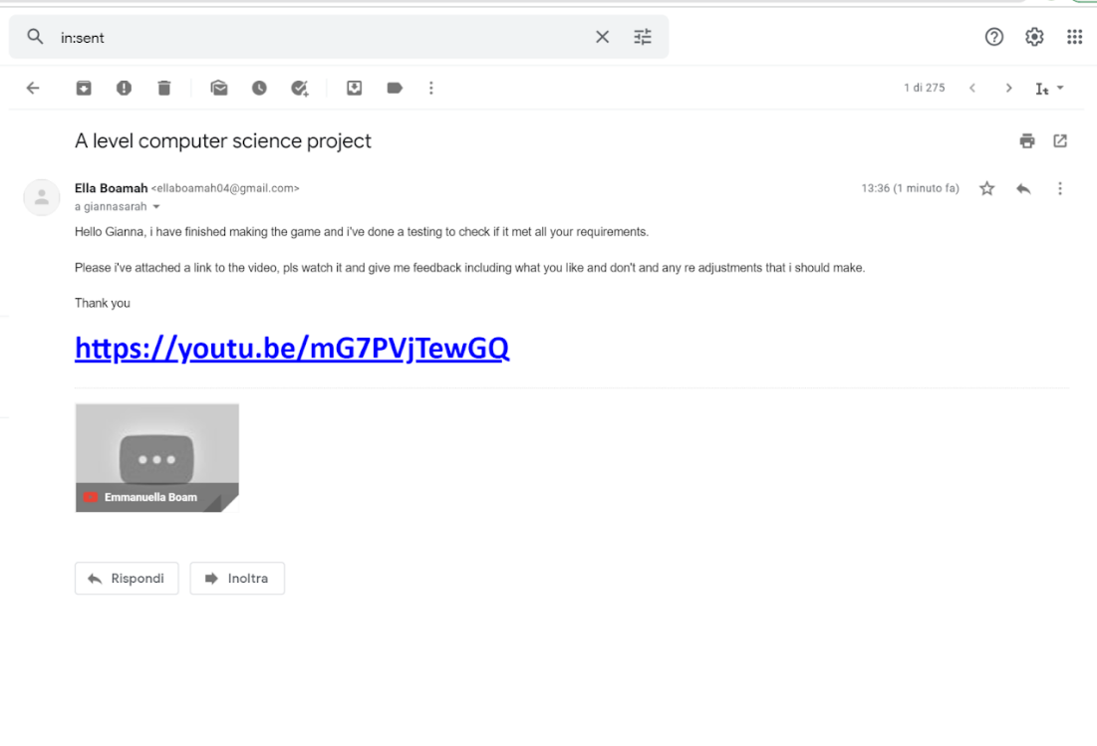
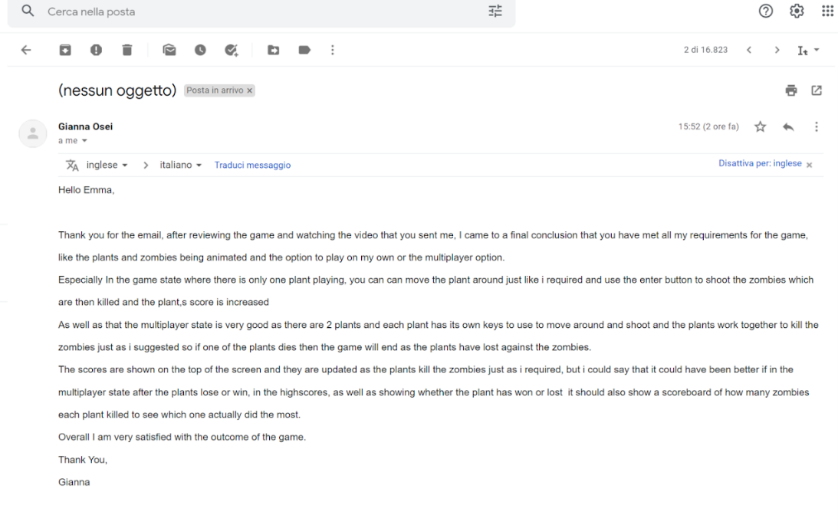
Improvements and final evaluations
Things i did good on
I managed to meet all the user requirements but there are some things that could have been done better for example, I could have stored the scores in a xml file and in the high score state showed the scores of each plant like the end user suggested in the feedback.
Could have used sql database or xml file to store scores

Even if the multiplier state was good for the end user, I could have done it in a different way using networks with a client and server and make the 2 users use it in different computers.
Could have used a server to to make it a networking programme

